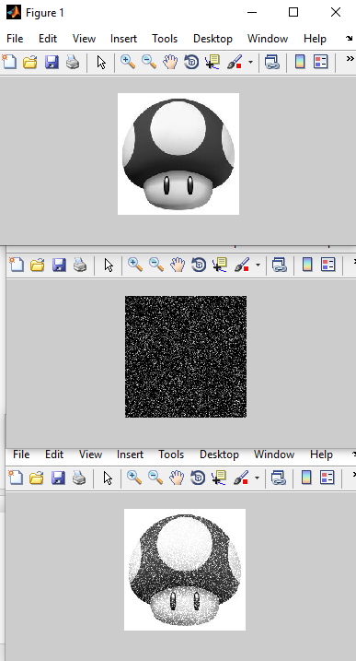

**PRODUIT DE CONVOLUTION N°1**

clc

clear all

close all

I1 = imread('pic.bmp');

[X, Y]=size(I1);

bruit=uint8(90*randn(X,Y));

I=I1+bruit;

figure(1), imshow(I1)

figure(2),imshow(bruit)

figure(3), imshow(I)